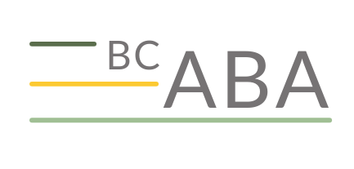

BC-ABA

Conference Travel Bursary Application

Personal Information
Last Name: First Name:
Address:
Email: Phone:

Proof of address. Bursary applicants must include a scanned copy or photograph of one of the following documents:
  - Driver’s license or BC ID with address
  - Bill with your name and address (e.g., hydro, telephone, cable, etc.)

